**Enhancing Image Captioning Through Integration Of Deep Learning And NLP Techniques**

**Abstract**

**This paper introduces a novel approach to image captioning by leveraging advanced techniques from both deep learning and natural language processing (NLP). Our proposed model aims to address the limitations of existing image captioning systems by integrating state-of-the-art methodologies. The paper provides a comprehensive overview of the project, starting with a motivation for the research, followed by technical details, experimental results, and in-depth analysis. The methodology employed is compared against baseline models, and insights into the successes and challenges encountered during the project are discussed.**

***Keywords: Deep Learning, Image captioning, Convolution Neural Network, MSCOCO, Recurrent Nets, Lstm, Resnet***

**INTRODUCTION**

The integration of deep learning and NLP has shown promising results in various domains, motivating our exploration of its potential for enhancing image captioning. The introduction outlines the background, significance, and objectives of the project. A brief review of existing literature on image captioning and relevant advancements in deep learning and NLP sets the stage for our proposed approach.

The aim of image captioning is to articulate the contents of an image, encompassing objects, actions, and various aspects, using natural language. While much of the past research has concentrated on generating single-sentence captions, this format has its limitations, as a brief statement can only capture a small portion of the image. Recent studies propose the adoption of image paragraph captioning, aiming to create a more detailed description consisting of usually 5-8 sentences to better explain a picture. This approach is relatively new compared to single-sentence captioning. The Visual Genome corpus, introduced by Krause et al. in 2016, serves as the largest dataset for paragraph captioning. However, existing algorithms struggle on this dataset, often producing repetitive paragraphs that fail to encompass a broad range of visual attributes, even when using techniques like beam search.

Several methods have been explored for generating paragraphs, including the Long-Term Recurrent Convolutional Network (LRCN), where a single image or a sequence of images from a video frame is processed through a Convolutional Neural Network (CNN) to identify visual features. The vector representation is then input into the Long Short-Term Memory (LSTM) model, generating words and forming a caption. This technique aims to ensure coherence and completeness in paragraph generation. Another approach involves using an attention model to recognize semantic regions in an image, producing sentences sequentially to construct a paragraph. Recurrent Neural Networks (RNNs), especially those like the gated recurrent unit (GRU), are favored for tasks requiring sequential inputs, such as speech and language prediction. The GRU, introduced by Cho et al., is a novel concept similar to the LSTM but without discrete memory cells. It utilizes gating units to regulate data flow, generating updating and reset gates for each hidden unit. The updated gate, influenced by the concealed state of the previous time step, determines the incorporation of new and old memory segments into the final memories. The reset gate, described by a distinct set of variables, controls the extent to which previous information influences the current hidden state.

**RELATED WORK**

This paper investigates the application of convolutional neural network (CNN)-based architectures for image captioning, where the goal is to label an image based on its prominent objects. Machine learning solutions, particularly those based on deep CNNs, have become prevalent for addressing image annotation challenges. Recent studies have introduced solutions that automatically generate human-like descriptions for images, a problem of practical significance that bridges two domains of artificial intelligence: Natural Language Processing (NLP) and Computer Vision. The CNN architecture that emerged victorious in the 2012 ImageNet Challenge has been widely employed for large-scale image and video recognition. Leveraging extensive image repositories like ImageNet and high-performance computing systems such as GPUs or distributed clusters, this architecture classifies a vast number of high-resolution images into different classes, achieving impressive error rates [2].

The neural network structure, comprising numerous neurons and parameters with multiple convolutional layers, has demonstrated substantial superiority over the state-of-the-art. Some layers incorporate max-pooling, followed by fully-connected layers culminating in a SoftMax layer. As ConvNets find growing applications in the computer vision community, efforts to enhance the original architecture proposed for improved accuracy have been undertaken. Recent work introduces an algorithm that selectively learns semantics, integrating them into the hidden and output states of a Recurrent Neural Network (RNN). This approach represents a noteworthy advancement in achieving a more nuanced understanding and description of image content [1].

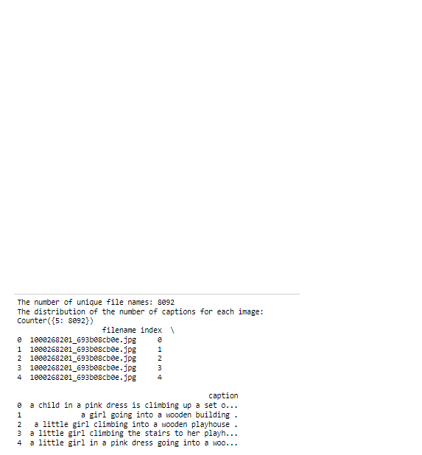Image captioning and visual question answering (VQA) represent challenges requiring the integration of image and language comprehension, driving significant research at the intersection of computer vision and natural language processing. Achieving high-quality outcomes in these tasks often demands fine-grained visual processing and, in some cases, multiple layers of reasoning. Current approaches, employing deep neural network architectures, enhance performance by learning to focus on the most crucial features of the image. This is accomplished through the utilization of a top-down attention mechanism and a faster R-CNN LSTM. Natural images inherently contain a wealth of semantic information and can be interpreted from various perspectives. However, existing methods for describing images are limited by a constrained set of biased visual paragraph annotations, often lacking coverage of diverse underlying semantics [3]. To address this, our study introduces a semi-supervised paragraph generation system capable of synthesizing varied and semantically consistent paragraph descriptions. This is achieved by reasoning over local semantic domains and leveraging language input. The proposed system incorporates a Sentence Discriminator, Topic Transition Discriminator, and an Adversarial Training Scheme to obtain the desired results [4].

**METHODOLOGY**

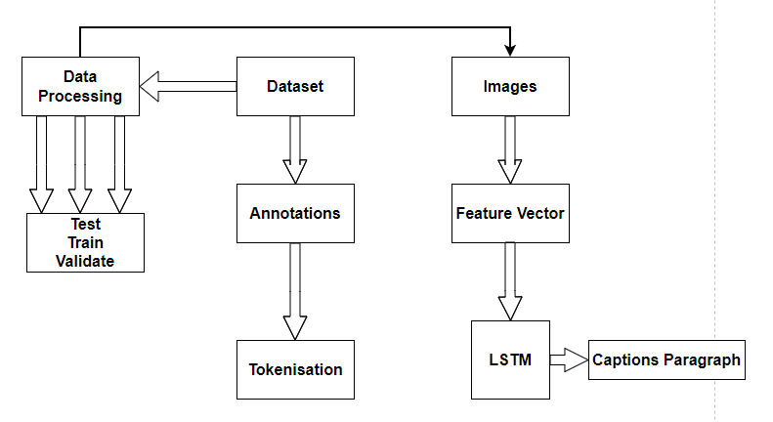

Figure . System Architecture

**Data Overview**

The project uses the Flickr8K dataset, which includes the texts and the images files. The captions are typically stored in a text file, and here it is named "Flickr8k.token.txt." and the "Images" files. The dataset contained 8092," indicating that there are 8092 JPEG files. the dataset comprises 8092 unique image file names, each associated with 5 captions. The dataset structure is organized with filename, index, and caption columns, providing detailed information about the images and their corresponding captions.

**Images and Captions Overview**

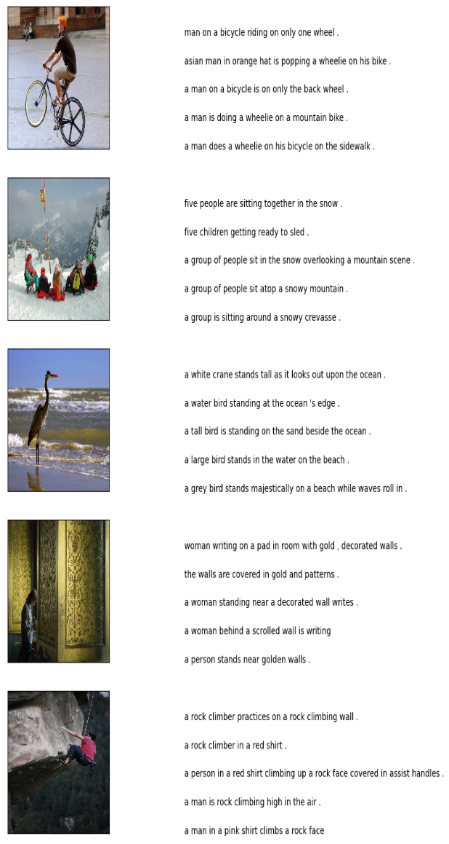

**Data Cleaning**

The data cleaning process involves splitting the text into individual words and then counting the number of occurrences of each word. This results in a vocabulary size of 1.

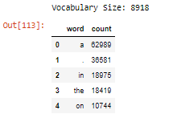

Cleaning captions typically involves preprocessing text data to make it suitable for analysis or training machine learning models. Common steps in cleaning captions for image datasets include: removing punctuation, removing special characters, and removing numeric value

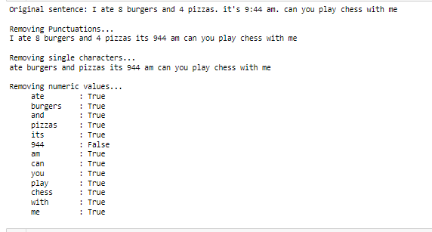

Plotting the top 40 and bottom 40 words that occur in the Cleaned Dataset

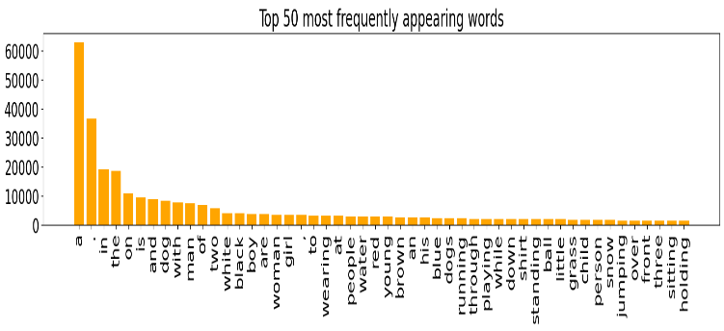 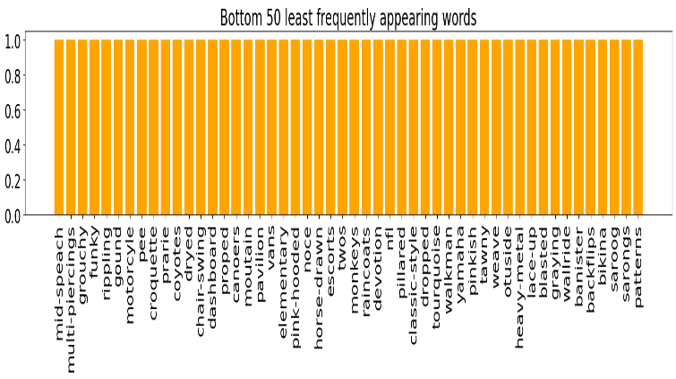

Start and End Sequence has to be added to the tokens so that it's easier to identify the captions for the image as each of them are of different length

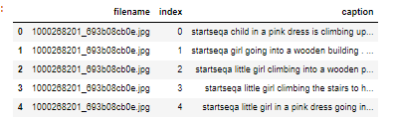

**SIMULATION AND RESULTS**

Some selected pictures that are cretaing clusters these are just to display the related images from the dataset

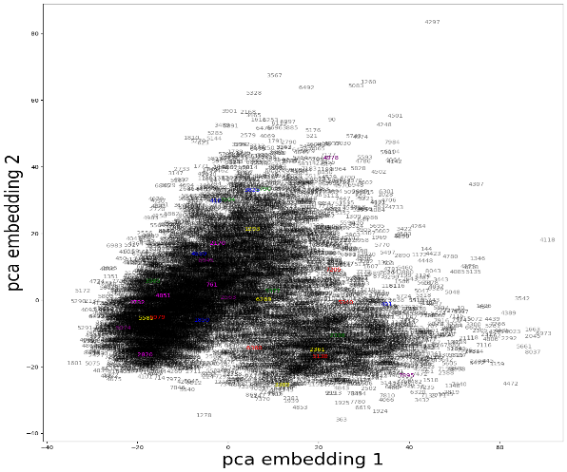

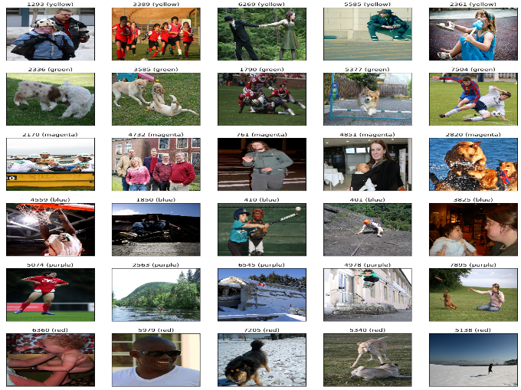

**TOKENIZATION**

Tokenization is the process of breaking down a text into individual units called tokens[5]. In the context of natural language processing, these tokens are typically words or subwords. Tokenization is a crucial preprocessing step in text analysis and machine learning tasks involving textual data.

**Vocabulary**



**EXTRACTING THE FEATURE VECTOR FROM ALL IMAGES**

Utilizing transfer learning, we leverage pre-trained frameworks to extract feature vectors from images rather than building everything from scratch. In this approach, we employ the Xception model, which has been trained on a vast ImageNet dataset with 1000 distinct classes. The keras.applications package conveniently includes this pre-trained model, and upon importing, the required weights are automatically downloaded, assuming an active internet connection.

As the Xception model was initially designed for ImageNet, we make slight adjustments for compatibility with our specific task. Notably, the model expects images with dimensions of 299x299x3. We aim to obtain a 2048-dimensional feature vector by excluding the last classification layer. This is achieved by using the parameters include_top=False and pooling='avg' when initializing the model. The function extract_features() is then employed to extract features from all photos, associating image identifiers with their respective feature arrays. Subsequently, the extracted features are stored in a dictionary and serialized into a "features.p" pickle file for future use.

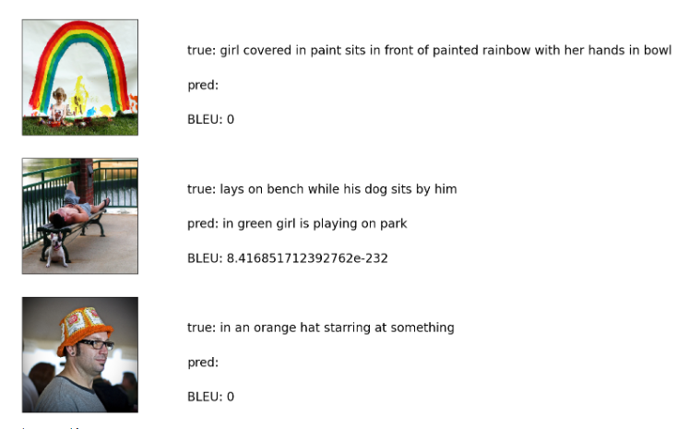

**CONCLUSION**

We employ human consensus scores for accuracy assessment, wherein participants are presented with a triplet of descriptors – one reference and two candidate descriptions. Their task is to select the candidate description that most closely resembles the reference. A metric is considered valid if it assigns a higher score to the human-chosen description that aligns more closely with the reference caption. This research primarily focuses on text captioning, as indicated in scholarly articles. Various captioning metrics are employed to evaluate machine-generated sentences, with scores reflecting the precision in word composition.

Our findings highlight the efficiency of the LSTM method, which yields optimal results on the Flicker 8K Dataset. However, certain limitations may exist, such as a constraint on the output length, with sections not exceeding 500 words or 4-5 lines. Consequently, this study illustrates the process of constructing a paragraph from a photograph, specifically employing the LSTM approach. While the project's scope is currently restricted to LSTM, future expansions are envisioned to enhance the system for broader scholarly utility. In the complex Python project undertaken, we developed an image caption generator to create a CNN-RNN model. It's essential to recognize that our model relies on existing data and may not predict concepts beyond its lexicon. The dataset used comprises 8000 images, and to achieve superior accuracy models, there's a requirement for training production-level models on datasets exceeding 100,000 images.

**REFERENCES**

1. The references have been reformatted to adhere to the AAAI citation style:
2. Zeiler, M. D., & Fergus, R. (2014). "Visualizing and understanding convolutional networks." In European Conference on Computer Vision (pp. 818-833). Springer International Publishing.
3. Simard, P. Y., Steinkraus, D., & Platt, J. C. (2003). "Best Practices for Convolutional Neural Networks Applied to Visual Document Analysis." In ICDAR (Vol. 3, pp. 958-962).
4. You, Q., et al. (2016). "Image captioning with semantic attention." In Proceedings of the IEEE Conference on Computer Vision and Pattern Recognition (pp. 4651-4659).
5. Vinyals, O., et al. (2014). "Show and tell: A neural image caption generator." arXiv preprint arXiv:1411.4555.
6. Young, P., et al. (2014). "From image descriptions to visual denotations: New similarity metrics for semantic inference over event descriptions." Transactions of the Association for Computational Linguistics, 2, 67-78.
7. Simonyan, K., & Zisserman, A. (2015). "Very Deep Convolutional Networks For Large-Scale Image Recognition." In International Conference on Learning Representation.
8. Krizhevsky, A., Sutskever, I., & Hinton, G. E. (2012). "Imagenet classification with deep convolutional neural networks." In Advances in neural information processing systems.
9. Karpathy, A., & Fei-fei, L. (2014). "Visual-semantic alignments for generating image descriptions." arXiv preprint arXiv:1412.2306.
10. Wei, Y., et al. (2014). "CNN: Single-label to multi-label." arXiv preprint arXiv:1406.5726.
11. Deng, J., et al. (2009). "Imagenet: A large-scale hierarchical image database." In Computer Vision and Pattern Recognition, 2009. CVPR 2009. IEEE Conference.
12. Deng, J., et al. (2009). "Imagenet: A large-scale hierarchical image database." In Computer Vision and Pattern Recognition, 2009. CVPR 2009. IEEE Conference.
13. LeCun, Y., et al. (1989). "Backpropagation applied to handwritten zip code recognition." Neural Computation, 1(4), 541-551.